Base rules civil war

* Daily updates

The map will be updated every 24 hours to correspond with changes in troop location and territory. The mods will own a version of the map with all troops, they will give each faction, if they request this, an update of the daily position.

In every period of 24 hours, every faction may send their troop movement, in accordance with the rules of how far units can move.

* Legend

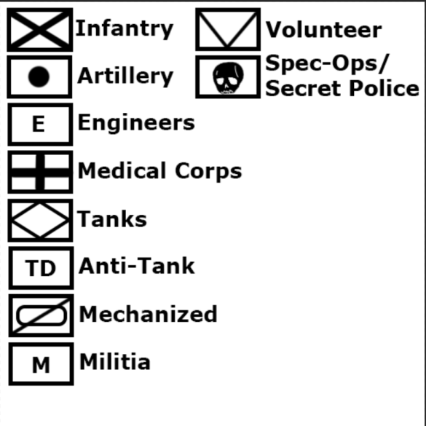

* Finances

Every 24 hours, each faction will be given their “daily allowance” that they can use in whatever way they choose (within the rules of course). The amount each faction gets is dependent on the number of cities they possess, foreign aid they have managed to scrape together, robbing villages and towns, and special events. Each small city grants the faction $2,000 to use. Large Cities, including the capital, will grant the faction $10,000 per day. Farmland produces grain and other valuable crops which will also be counted as income. The total amount of farmland occupied by a faction will be used to determine how much they make (total perimeter of the area controlled x 2 ). Finally, all factions have a default income of $4,000 to use regardless of their circumstances. The mods will calculate your income for you, but once they do you should be able to figure out the costs of purchases on your own.

* Unit Costs (every 24 hours, new unit may be deployed)

Infantry Cost: $500, Infantry Upkeep: $50/day

Artillery Cost: $600, Artillery Upkeep: $60/day

Engineer Cost: $600, Engineer Upkeep: $60/day

Medic Cost: $600, Medic Upkeep: $60/day

Tank Cost: $1,000, Tank Upkeep: $100/day

Anti-Tank Cost: $600, Anti-Tank Upkeep: $60/day

Mechanized Cost: $800, Mechanized Upkeep: $80/day

Secret Police/Special Forces: Cost: $2000, SP/SF Upkeep: $200/day

Militia Cost: $200, Militia Upkeep: $20/day

Volunteer Cost: $50, Volunteer Upkeep: $0

**note: you are allowed to underpay soldiers, however doing so will affect their morale and discipline

* Unit movement (km are equivalent to pixels on the 4,000 by 4,000 original pixel map)

Infantry: 20 km/day

Artillery: 200 km/day

Engineers: 200 km/day

Medical Corps: 200 km/day

Tanks: 200 km/day

Anti-Tank: 20 km/day

Mechanized: 250 km/day

Militia: 20 km/day

Volunteer: 20 km/day

Spec-ops: 250 km/day

*add 100km/day to all units on roads!

* Unit Descriptions:

Infantry: The heart and soul of the army. These war-hardened soldiers often make up the largest portion of the forces. While very slow moving, they are consistent, and have an average level of morale and discipline. They are particularly weak against armoured units such as Tanks and Artillery, but overall, they are reliable soldiers.

Artillery: Artillery reach where the infantry can’t. Works well at long range, deadly against un-armoured units, and effective against armoured ones. However, while great offence, they significantly lack defense and are easily taken down if left unprotected.

Engineers: Slightly less effective infantry that lower the chances of vehicles and armoured units malfunctioning(artillery, tanks, mechanized, etc). Additionally, if a vehicle is damaged, it can only be repaired if an engineer is present during or after the battle.

Medical Corps: Medics are the un-armoured versions of Engineers. Medics lower casualties among unarmoured units and decrease the effectiveness of artillery barrages and bombings.

Tanks: Tanks are the units with the best defense in the game. They are excellent against infantry, but vulnerable to artillery and anti-tank guns. Additionally, when attacking, they lose almost all effectiveness in marsh terrain. (they lose some effectiveness in hills, but not much).

Anti-Tank: Generally only effective against Tanks.

Mechanized: The faster, cooler, brother of the infantry. While more costly to have, mechanized are less vulnerable to artillery and tanks while increasing their overall speed and reliability.

Secret Police/Spec Ops: Do you want a high ranking official assassinated? Do you want to infiltrate enemy bases or sabotage their vehicles? Then hire SP/Sos! These units are the most trained and effective soldiers in the game. SOs are effective in all terrains and have a near unbreakable morale and discipline.

Militia: These units are the less effective versions of the infantry. Will they always hit their mark? No, probably not, but they still give it their all! Also, they’re kinda cheap so that’s cool too.

Volunteers: Volunteers are literally what would happen if the average next-door neighbor suddenly became radically political and decided to enlist in the military. These units have probably never picked up a gun before, but that doesn’t mean they aren’t willing to die for their country! They can’t shoot straight and will probably desert the battlefield after a few hours, but hey, you only have to pay for their weapon and uniform!

* Battles

Battles will be entirely RPd by the players/mods. There will be no dice rolls. There will be a map with a layout of the battlefield where each faction(s) may plan out a strategy before hand. If this becomes too hectic/complicated, we may have to revert to using dice.

* Foreign powers

This Mechanic has not been released yet

* Terrain:

Terrain only determines two things: what the battle map will look like and whether there are any negative side effects during the battle. Tanks and Mechanized Infantry barely function in marshes and work subpar in hills. Naval invasions work particularly well in beaches and terribly in hills. Also, Mechanized/Armoured units do not work well in forests.

NAVY (Work in progress)

AIRFORCE(Work in Progress)

* Victory conditions

**All other factions are either destroyed or have surrendered.**

(It is also possible to create peace treaties in which a certain faction gains independence/confederation)